Task: Cybersecurity Task2(2026) – future interns
Topic: Phishing Email Detection & Awareness system

Executive summary
Phishing remains as one of the most common and damaging cyber threats to businesses. Attackers impersonate trusted brands to trick users into clicking malicious links or sharing credentials. This report shows and analyses three phishing email samples using header analysis and HTML inspection tools. Each sample shows or rather demonstrates how attackers exploit urgency, fake domains and missing authentication records to deceive recipients.

Risk Rating

Email | Subject | Risk Level | sender | Authentication | Main indicator | Classification
Sample 1 | Bradesco Livelo Points | High | Banco.bradesco@ubuntu | SPF/DKIM/DKMARC failed | Fake banking domain | Phishing
Sample 2 | Microsoft sign-in activity | High | No-reply@access-accsecurity.com | SPF none, DKIM none, DMARC perm Error | Fake Microsoft alert | Phishing
Sample 3 | Solar Panel offer | Medium-high | zonnepaneel@appjj.serenitepure.fr | SPF none, DKIM none, DMARC none | Fake solar promotion | Phishing

Tools used
TOOL | PURPOSE
Google message header analyser | Extract and interpret email header metadata
Mx toolbox email header analyser | Verify SPF, DKIM & DMARC records
Text editor(notepad) | View raw HTML content safely

Phishing email samples analysed

Sample 1: Bradesco Livelo Points Expiration
Subject: CLIENTE PRIME – BRADESCO LIBELO: Seu cartão tem 92.990 pontos LIVELO expirando hoje!
From: banco.bradesco@ubuntu-s-1vcpu-35gb-intel-sfo3-06
SenderIP: 137.184.34.4 (blacklisted)

Header Analysis:
- SPF = temperror (IP unknown)
- DKIM = none (message not signed)
- DMARC = temperror
- Authentication failed – spoofed sender
Link Inspection:
The domain blogseguimentmydomain2bra.me is unrelated to Bradesco and currently inactive.
Evidence:
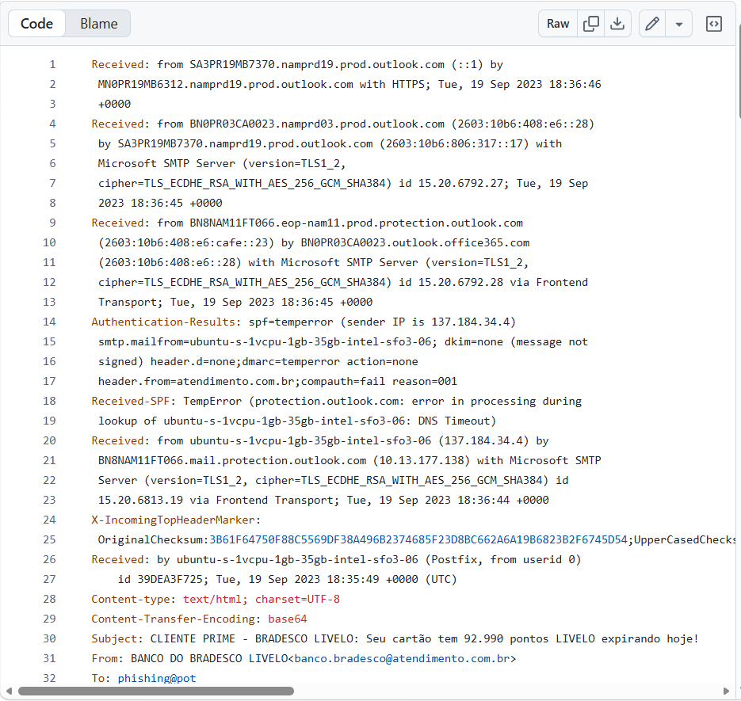 This is the raw email
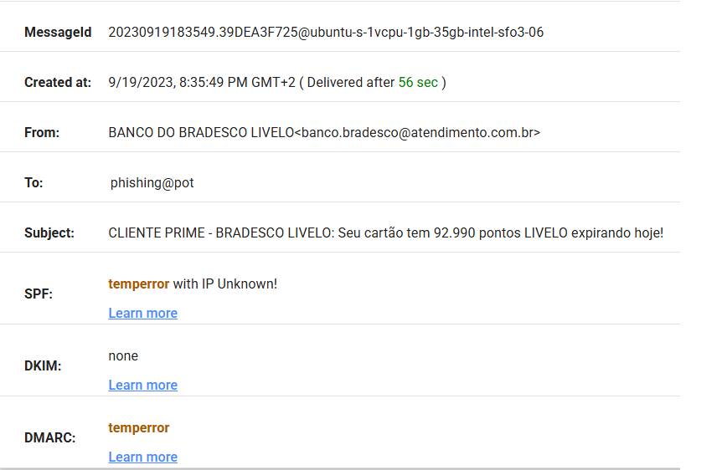

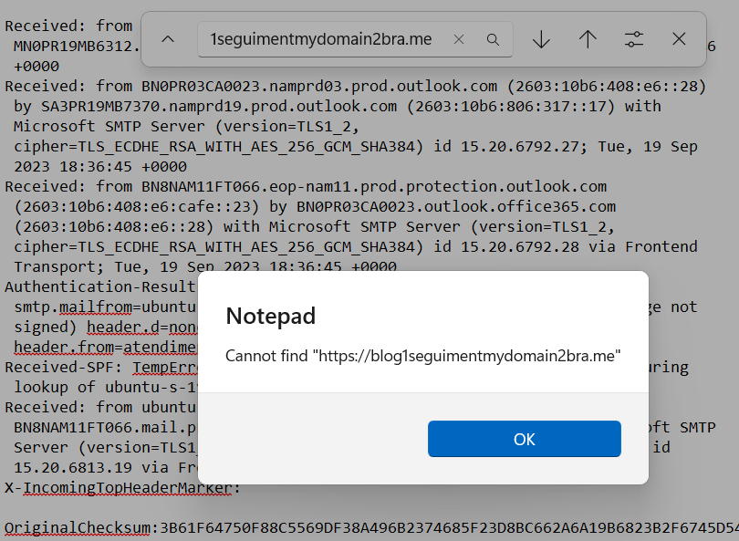

Risk Classification: Phishing
Indicators: Fake sender domain, failed authentication, malicious redirect link, urgency language.

Sample2- Microsoft Account Unusual Sign-in Activity
Subject: Microsoft account unusual sign-in activity
From: no-reply@access-accsecurity.com
Return -path: bounce@thcultarfdes.co.uk
SenderIP: 89.144.44.2
Header Analysis:
- SPF = None (sender IP not authorised)
- DKIM = None (email not digitally signed)
- DMARC = PermError (DMARC validation failed because of configuration problems)
- Domain access-accsecurity.com is not a Microsoft domain.
Link inspection: HTML body contains a redirect to sotrecognizd@gmail.com a fake security domain.
Evidence:
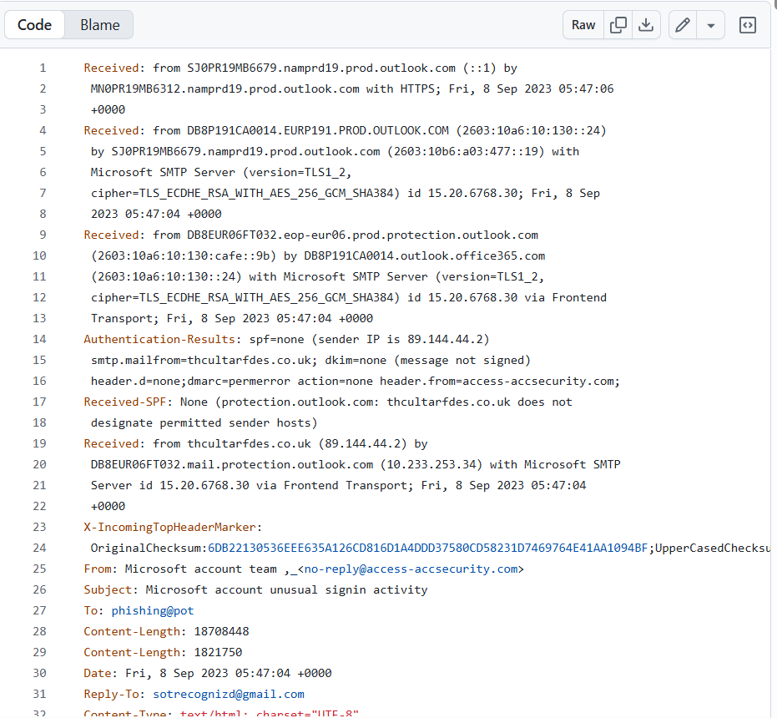This is the raw email
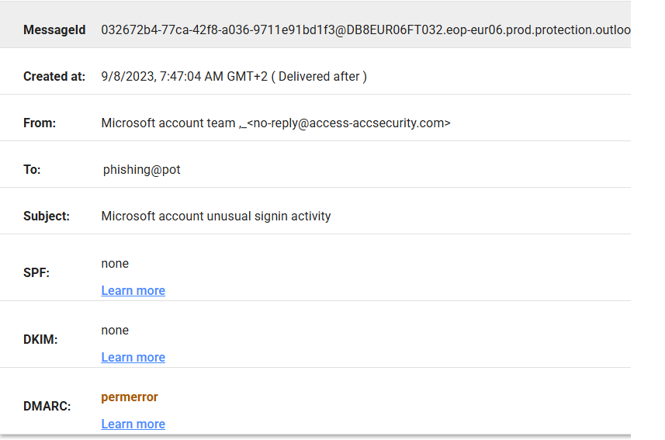
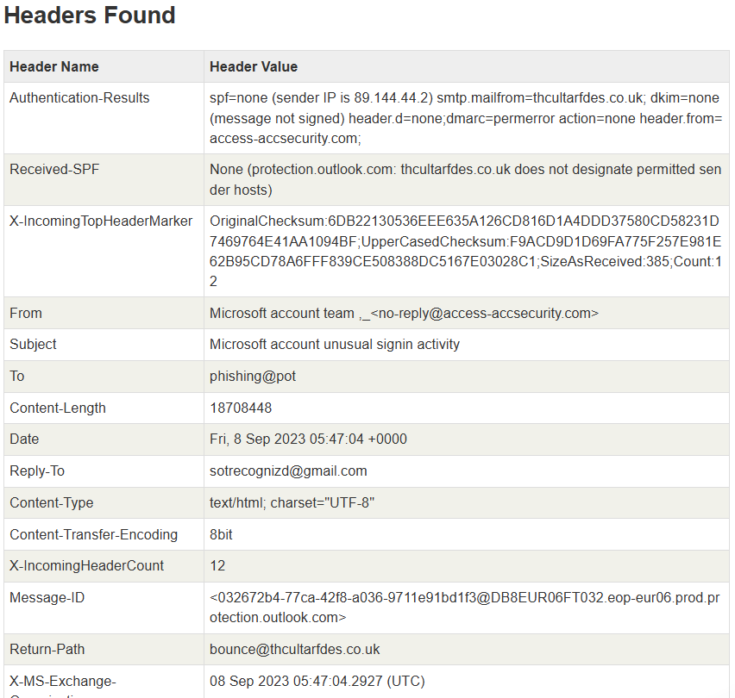
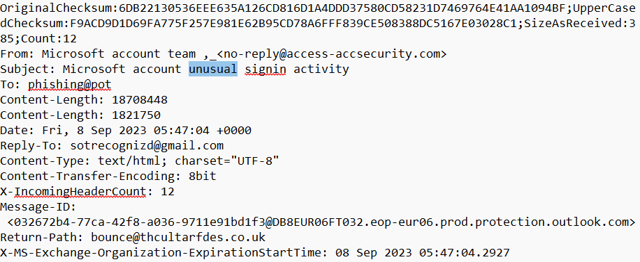 It creates Fear and Urgency
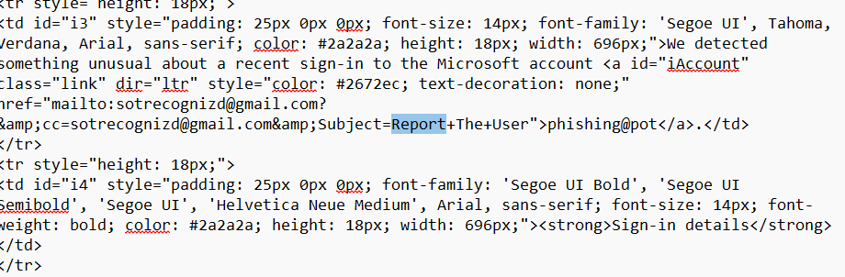it uses a mailto: link instead of taking users to Microsoft’s official security portal.
Risk Classification: Phishing
Indicators: spoofed Microsoft sender, no authentication. Fake security domain

Sample 3- Solar Panel Offer
Subject: Zonnepanelen vooreen goede prijs
From: zonnepaneel@appjj.serenitepure.fr
SenderIP: 57.128.69.202
Header Analysis:
- SPF = none - the sender could not be verified, increasing the likelihood that email address was spoofed.
- DKIM = none - the sender could not be verified, increasing the likelihood that email address was spoofed.
- DMARC = permerror
- Domain serenitepure.fr unrelated to energy providers.
Link Inspection: No <a href> tags found- plaintext URL embedded in body.
Evidence:
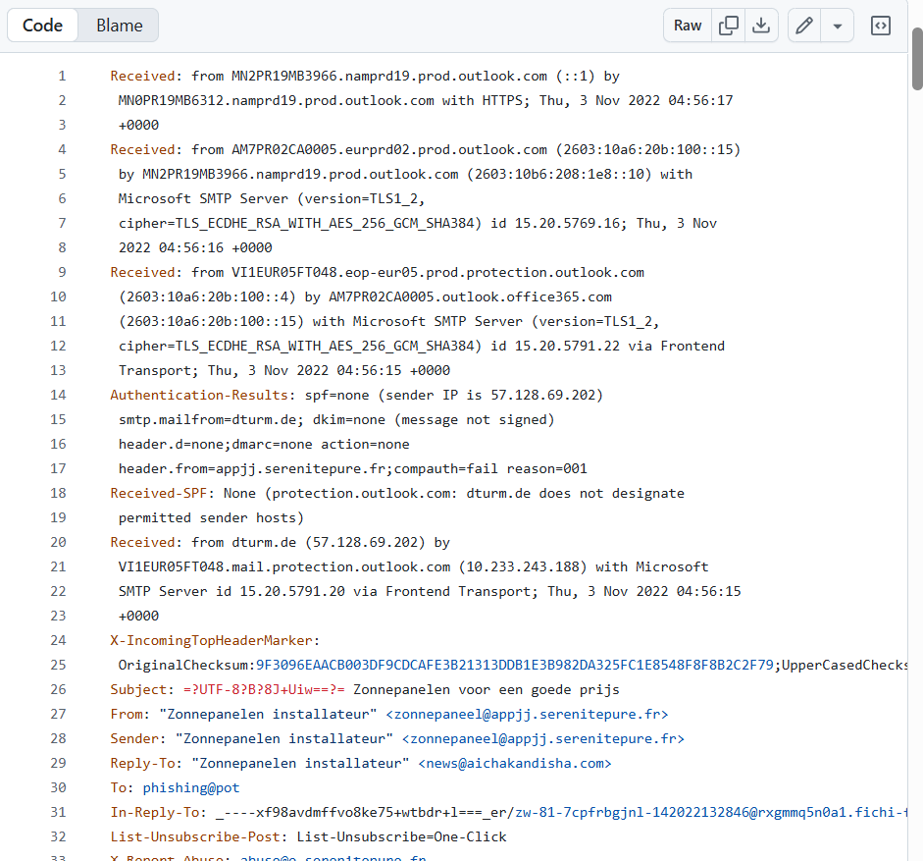This is the raw email
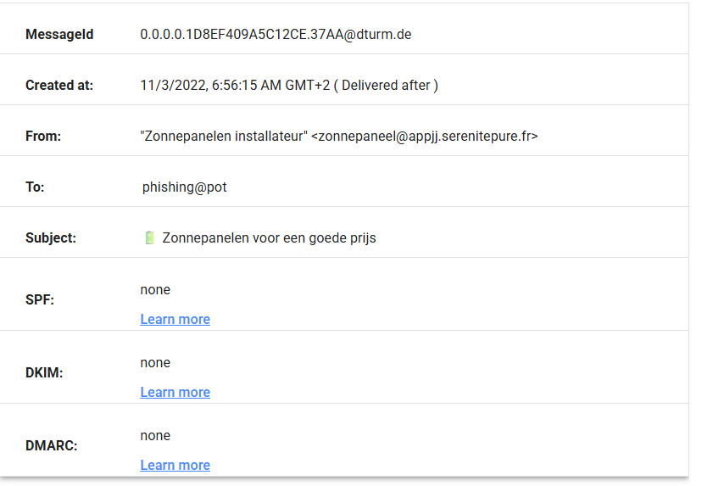
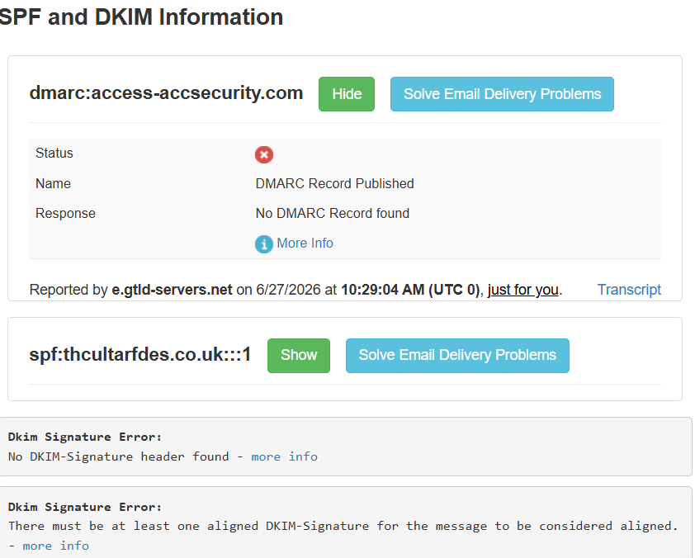
Risk Classification: Phishing
Indicators: unverified sender, generic offer, no authentication records.

Common Phishing Indicators
Indicator | Description
Fake sender domain | Domain does not match organization name
Failed SPF/DKIM/DMARC | Email cannot be verified as legitimate
Urgency or fear language | “Expiring today”. “Unusual activity”
Suspicious links | Redirects to non-official domains
Generic Greetings | “Dear user “instead of personal name

How The Attack Works

Attackers create emails that look real/legit, but it redirects users to fake website so that they can steal credentials or financial data. They usually use spoofed domains and disable authentication records to bypass filters.

Prevention and Awareness Guidelines
- DO’S
- Verify sender domain before clicking links
- Hover over links to see real destination
- Report suspicious emails to IT or security team
- Use multi-factor authentication for accounts
 Don’ts
- Don’t click unknown links or attachments
- Don’t share password or OTP codes via email
- Don’t ignore authentication warnings from email clients

Conclusion
All the three analysed emails show common phishing techniques used by cybercriminals, including domain spoofing, missing email authentication records, misleading branding, fake sender identities and urgency-based social engineering. The header analysis together with inspection of sender domains and embedded links clearly shows each email as malicious and avoiding suspicious links is an effective method for detecting phishing attempts before users become victims.

